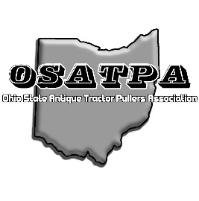
The Ohio State Antique Tractor Pullers Association, OSATPA, is soliciting sponsors for the 2024 tractor pulling season. We are excited to announce that again for 2024, the OSATPA will be holding all our events at the Shelby County Fairgrounds in Sidney Ohio, except for the Annual Plain City Thresher Pull. The organization invites you to be a sponsor for our non-profit organization.

With your sponsorship, your company’s name will be included on our list of 2024 sponsors on our website, Facebook page, and (depending on your sponsorship level) the Annual Plain City Thresher Magazine. We will also announce your sponsorship during our events.

The OSATPA was founded in 1999. The OSATPA is composed of all ages; from seasoned veterans with 20+ years of pulling experience to first year, first time pullers. Our classes allow a place for most to pull. Classes range from Division 1, stock class style pulling all the way up to Division 4, open antique class tractors a well as the Altered Farm Stock Classes. The OSATPA participates jointly with the Threshers event at Pastime Park in Plain City. The Thresher’s event continues to draw record hooks and great prize money. http://www.OSATPA.com

Thank you for your support and contribution. Your sponsorship will help assure the success of our 2024 pulling season!

Our sponsorship deadline is April 1, 2024.

Please complete this form and include a business card and/or logo for the art work.
Please remit you check (payable to OSATPA) to:
Linda Beasley, Treasurer OSATPA
P.O Box 43
Sidney, Ohio, 45635
Phone: 937-606-0884
Email: danandlin2000@gmail.com

Company or Individual Name: _____________________________________________________
Authorized by (name & title): _____________________________________________________
Mailing Address: _______________________________________________________________
City, State, Zip: _________________________________________________________________
Phone Number: ________________________________________________________________
Email Address: _________________________________________________________________
Signature: ____________________________________________________________________
Date: ________________________________________________________________________
Please check one of the Sponsorship amounts below:
$50.00 ____ $100.00 ____ $200.00 ____ $300.00 ____
$400.00____ $500.00 ____ Corporate Sponsor $1000.00 _______

